# Assignment Block 2

# SpamHaus

**DRAFT**

Group 8

Jorrit van den Spek, Hugo Bijmans, Eveline Pothoven, Ben Hup, Lisette Altena

WM0824 Economics of Security

# Table of Contents

1. Security Issues 1

2. Ideal metrics for security decision makers 2

3. Existing metrics 3

4. Metrics from dataset 4

5. Evaluation of the defined metrics 5

Methodology 5

Reliability issues 5

6. References 6

# 1. Security Issues

Spam, it is a major source of frustration for internet users. More than halve of the e-mail traffic consists of spam (Figure 1). It causes high costs for companies. Employees who could otherwise spend their time on more productive work, waste their time. Network errors, which are among others caused by employees responding to spam mail, largely impacts the productivity. Furthermore spam uses storage and bandwidth, which could otherwise be used for useful purposes, spam filters might unfairly block emails, because of which emails are delayed. (http://www.windowsecurity.com/whitepapers/anti_spam/Impact-Reducing-SPAM-Part1.html)

Besides the fact that spam impacts businesses by wasting a lot of time, it affects the environment as well. Spam expert Richi Jennings calculated together with climate change consultant ICF International the environmental impact of spam. According to the study, the energy consumed in transmitting and deleting spam last year (62 trillion) is similar to the amount of electricity used in 2.4 million U.S. homes. (https://resources2.secureforms.mcafee.com/LP=2968).

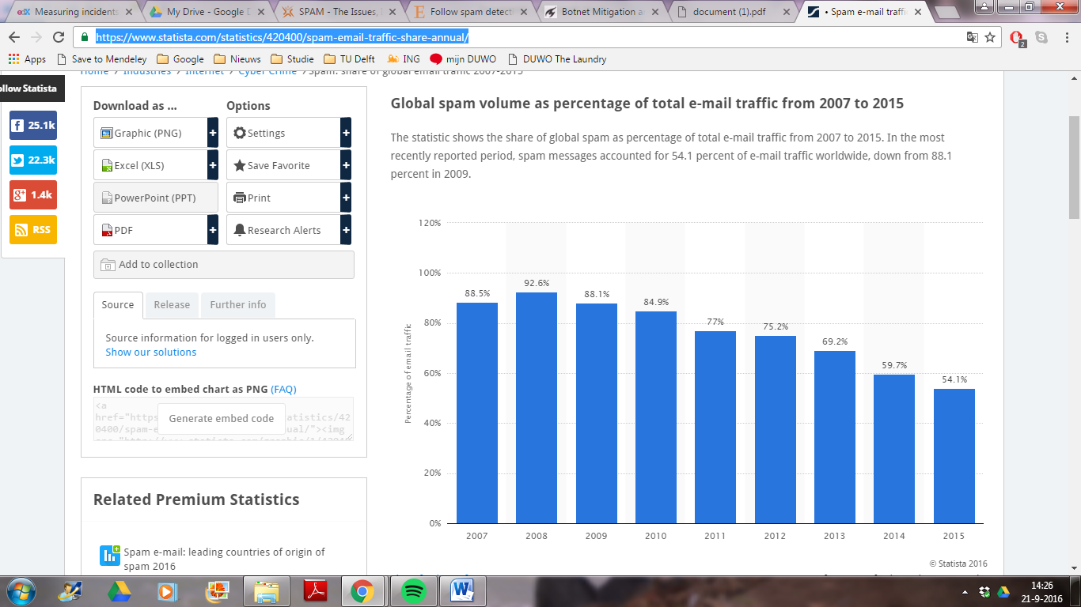

Figure 1: Global spam volume as a percentage of total e-mail traffic from 2007 to 2015, source: https://www.statista.com/statistics/420400/spam-email-traffic-share-annual/

Email is considered spam if it is unsolicited and sent in bulk. Besides junk mail from businesses to advertise goods, emails containing viruses are also considered spam. Another category of spam mail sends the receiver to websites that contain scripts to collect information for the purpose of identity theft and other criminal operations. The mail could also contain links that claim to take you of the mailing list, but in fact the intention is to verify whether the email is actively used.

# 2. Ideal metrics for security decision makers

# The metrics for security decision makers should consist of metrics based on all four types. In practice metrics are usually based on control and a bit on vulnerability. This is because controls are closely related to the cost and are put in place to mitigate risk. Metrics based on vulnerabilities evaluate how these controls preform under threat. These metrics are deterministic in contrast to the metrics based on incidents and the prevision of loss, whom are based on events driven by attackers and are therefore stochastic. They map the losses whenever a curtain events occurs. Implementing these metrics is resource consuming and are used less.

# There are a lot of decision makers dealing with the issue of spam. In the next section the most important decision makers will be mentioned with specific metrics that are useful to them.

# First of all there are the users who receive the spam. The users can be separated into private and corporate users. For both the matric: ratio of spam received to average amount of spam, can help them understand if they are targeted. The matric; income loss by employees engaging in spam and income loss by false negatives is also of great value to decision makers from companies. The internet service providers can use the following metric to help the make security decisions. The amount of spam received by their clients. They can compare this matric with other Internet services providers to indicate if their security measures are adequate. A Metric that can be used by the criminals who use botnets to send spam is; success rate of spam bombs. With this metric criminals can pinpoint weaknesses in the security and exploit it. The amount of competing botnets with their relative size can be used for economic purposes. Governments are interested in metrics that calculate economic losses and the amount of damage done by engaging in spam. Last there are the email software developers, they would use metrics to indicate if their platform is targeted and has weak spots. Metrics like the amount of false positives and amount of spam send to their domain could help the software developers.

# In conclusion the ideal metrics for security decision makers consist of a mix of already existing metrics from the four types and specific metrics suited for the activities different security decision makers have.

# 3. Existing metrics

Security metrics are very important. Nowadays, the economic climate does not allow spilling resources for information security: they are limited. The security spending must be justified and allocated. Therefore, the right metrics are necessary. If one invests a lot in information security, he wants to get actual security, and reap certain benefits (bron: online lecture 2.2).

But what ‘information security’ is a wide concept. In this project, the main focus is Spam, regarding the project SpamHaus.

If one takes a look at current literature, more and more articles are written about metrics and information security: an upcoming field. Already in 2008, Zhuang was talking about metrics in the world of spam. His metrics mainly focused on botnets, and listed three metrics (Zhuang, 2008):

1. **Capability of botnet controllers**: estimate the total size of each botnet based on their 9 days of observation in the experiment
2. **Level of activity (botnet)**: estimate the active working set of each botnet in a short time window, such as one hour. Think of the spam sent (such as the number of spam emails) per botnet
3. **Active size (botnet):** the number of machines/IPs used for sending spam email messages by this botnet during this short time window

If one looks a bit further in literature, you might find a surprising amount of information. But there is one very useful paper, summarizing all this information and insights about spam metrics. Moura and Van Eeten (2015) listed a summary of current botnet metrics. First, they pointed out what the requirements of useful metrics are, such as ‘comparative over time’ and ‘comparability’.

Secondly, they carried a literature review on the current metrics, and proposed a classification of these metrics into three categories:

1. **IP-based**: metrics using the originating IP address of traffic related to infected machines
2. **Host-based**: metrics based on data that directly and reliably indentifies individual hosts on the internet.
3. **Proxy-based**: metrics that are estimations based on traffic volume associated with botnets (Moura&van Eeten, 2015)

These categories are shown in the second column of the table. The other columns quite speak for themselves, the last three might need some more explanations. The categories presented above can be further extended: by aggregation (per country for example), by normalization, or by ranking: being turned in a rating, based on a different scale than the original metric.

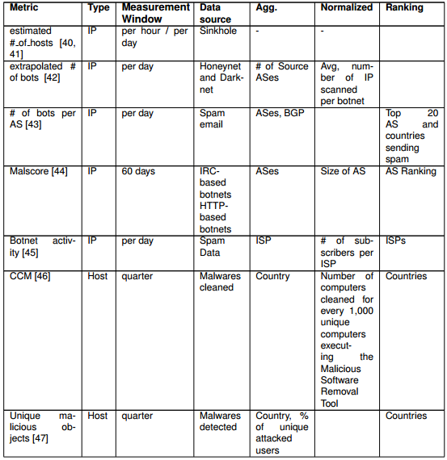Table 1: summary of current botnet metrics (Moura & van Eeten, 2015)

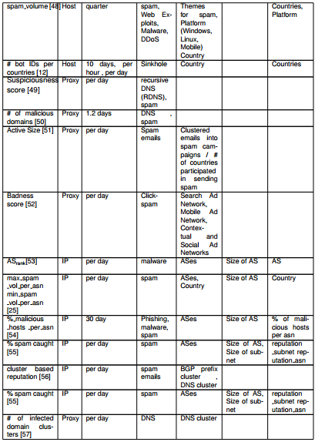

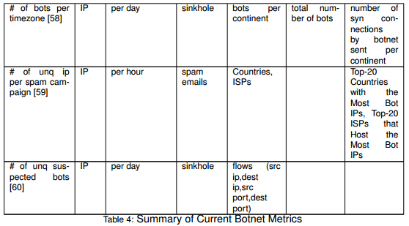

# 4. Metrics from dataset

Using the dataset, a few metrics are defined. More information follows.

* Unique no. of IP addresses per botnet
* Top 10 countries per botnet
* Top 10 ISP hosting botnets
* Top 10 spam sending countries
* Botnet activity over time
* Number of botnets active per country
* Amount of countries active per botnet

# 5. Evaluation of the defined metrics

## Methodology

## Dataset was built of 10.554.552 rows and 8 columns. Before analysing the dataset, some cleaning had to be done. Firstly a random row in the middle of the dataset, containing the names of the columns, was removed. Next, all the records which did not contain a timestamp or an ASN number were removed. At the end 15.636 records were removed (which is 0.14% of all the data in the data set). The final dataset contains 10.538.915 to work with. SPSS was used to clean the data, R was used to analyse the data.

## Metrics

Unique number of IP addresses per botnet  
Since every IP address is unique in this dataset, this is a very straightforward question to answer. Using this R command, we were able to check which botnets contained the most IP addresses:

summary(spamdata$Diagnostic)

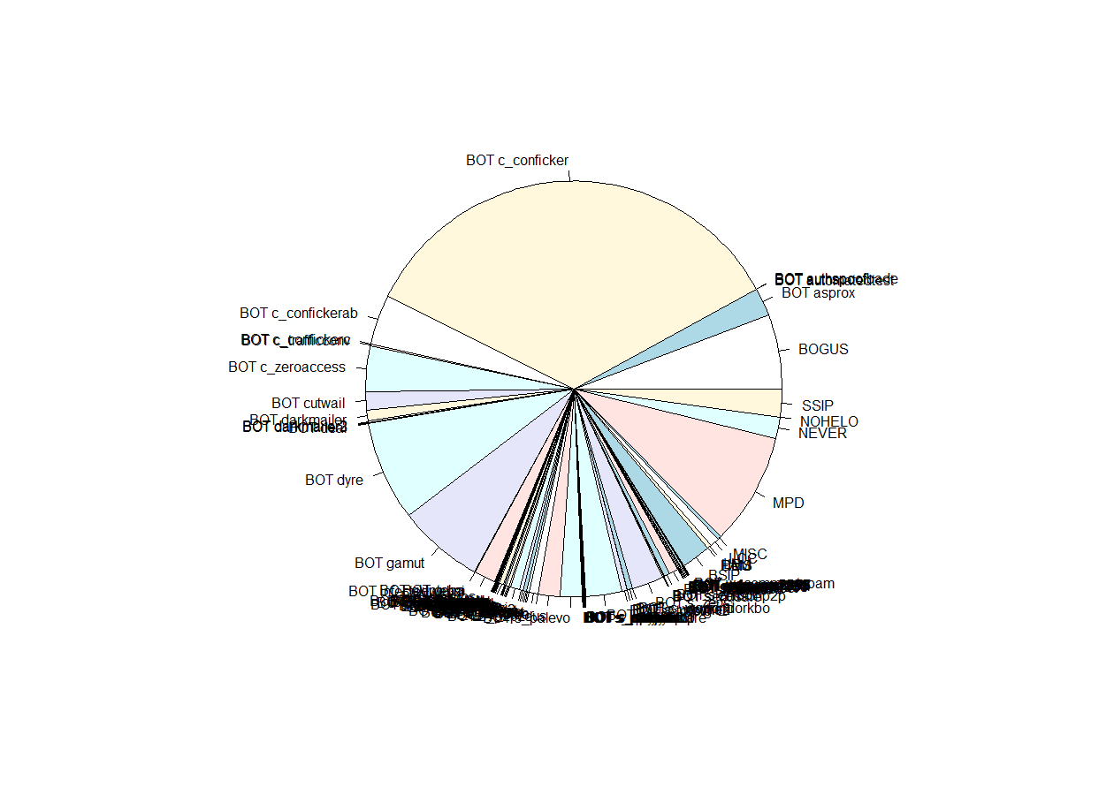

|  |  |  |  |
| --- | --- | --- | --- |
| **Rank** | **Botnet** | **#IP addresses** | **% of total** |
| 1 | BOT c_conficker | 3654641 | 35% |
| 2 | MPD | 920926 | 9% |
| 3 | BOT dyre | 818051 | 8% |
| 4 | BOT gamut | 705992 | 7% |
| 5 | BOGUS | 610905 | 6% |
| 6 | BOT c_confickerab | 404182 | 4% |
| 7 | BOT c_zeroaccess | 369457 | 4% |
| 8 | BOT s_tinba | 301139 | 3% |
| 9 | BOT s_zeus | 258807 | 2% |
| 10 | BSIP | 242669 | 2% |

### Top 10 countries hosting Botnets

Investigating the ASN codes present in the dataset, we were able to see which providers hosted the most infected computers who were sending spam. The ASN codes are resolved using the RIPE Database at <https://apps.db.ripe.net/search/query.html#resultsAnchor>

summary(spamdata$ASN)

|  |  |  |  |  |
| --- | --- | --- | --- | --- |
| **Rank** | **ASN Number** | **Name** | **Country** | **#records** |
| 1 | AS4134 | CHINANET-BACKBONE | CHINA | 701.205 |
| 2 | AS45899 | VNPT-AS-VN | VIETNAM | 693.424 |
| 3 | AS9829 | BSNL-NIB | INDIA | 501.901 |
| 4 | AS17974 | TELKOMNET-AS2-AP | INDONESIA | 286.744 |
| 5 | AS7552 | VIETEL-AS-AP | VIETNAM | 200.668 |
| 6 | AS45595 | PKTELECOM-AS-PK | PAKISTAN | 198.701 |
| 7 | AS18403 | FPT-AS-AP | VIETNAM | 177.056 |
| 8 | AS4837 | CHINA169-Backbone | CHINA | 167.542 |
| 9 | AS3462 | HINET | TAIWAN | 143.430 |
| 10 | AS8151 | Uninet S.A. de C.V. | MEXICO | 133.791 |

### Top 10 countries sending SPAM

Investigating the country field in our dataset gives the following results. Achieved by using this query:

summary(spamdata$Country)

|  |  |  |  |  |
| --- | --- | --- | --- | --- |
| **Rank** | **Country Code** | **Country** | **#records** | **% of total** |
| 1 | VN | Vietnam | 1162444 | 11% |
| 2 | IN | India | 1152149 | 10% |
| 3 | CN | China | 1098155 | 10% |
| 4 | RU | Russia | 579619 | 5% |
| 5 | BR | Brazil | 480780 | 5% |
| 6 | ID | Indonesia | 357036 | 3% |
| 7 | IR | Iran | 285827 | 3% |
| 8 | US | United-States | 268296 | 3% |
| 9 | IT | Italy | 252711 | 2% |
| 10 | PK | Pakistan | 250058 | 2% |

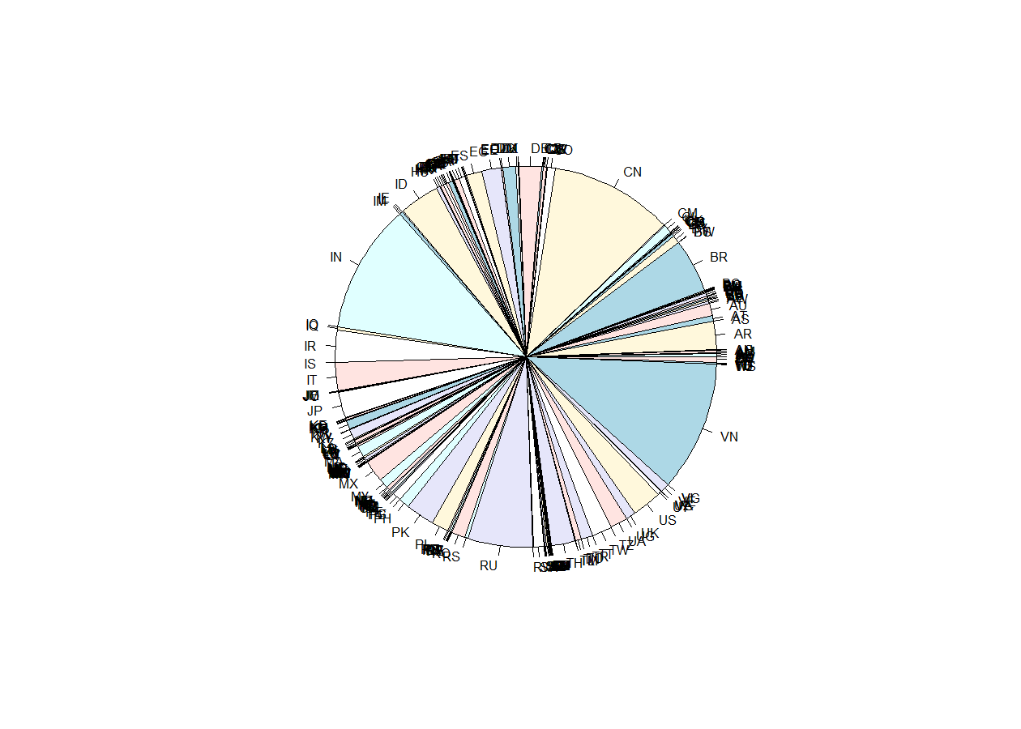

Top 10 countries per botnet  
The 10 most popular botnets are operated from the same countries. In this table, you’ll see an overview. This means that the biggest botnets are using bots located in India, but more smaller botnets use Vietnamese infected computers to perform spam attacks.

aggregate(Country ~ Diagnostic, summary, data=spamdata)

|  |  |  |  |  |  |
| --- | --- | --- | --- | --- | --- |
|  | **BOT c_conficker** | **MPD** | **BOT dyre** | **BOT gamut** | **BOGUS** |
| 1 | Country.IN | Country.IN | Country.IN | Country.IN | Country.IN |
| 2 | Country.CN | Country.CN | Country.CN | Country.CN | Country.CN |
| 3 | Country.PK | Country.PK | Country.PK | Country.PK | Country.PK |
| 4 | Country.RU | Country.RU | Country.RU | Country.RU | Country.RU |
| 5 | Country.IR | Country.IR | Country.IR | Country.IR | Country.IR |
| 6 | Country.US | Country.US | Country.US | Country.US | Country.US |
| 7 | Country.VN | Country.VN | Country.VN | Country.VN | Country.VN |
| 8 | Country.MX | Country.MX | Country.MX | Country.MX | Country.MX |
| 9 | Country.PE | Country.PE | Country.PE | Country.PE | Country.PE |
| 10 | Country.BR | Country.BR | Country.BR | Country.BR | Country.BR |

|  |  |  |  |  |  |
| --- | --- | --- | --- | --- | --- |
|  | **BOT c_confickerab** | **BOT c_zeroaccess** | **BOT s_tinba** | **BOT s_zeus** | **BSIP** |
| 1 | Country.IN | Country.IN | Country.IN | Country.IN | Country.IN |
| 2 | Country.CN | Country.CN | Country.CN | Country.CN | Country.CN |
| 3 | Country.PK | Country.PK | Country.PK | Country.PK | Country.PK |
| 4 | Country.RU | Country.RU | Country.RU | Country.RU | Country.RU |
| 5 | Country.IR | Country.IR | Country.IR | Country.IR | Country.IR |
| 6 | Country.US | Country.US | Country.US | Country.US | Country.US |
| 7 | Country.VN | Country.VN | Country.VN | Country.VN | Country.VN |
| 8 | Country.MX | Country.MX | Country.MX | Country.MX | Country.MX |
| 9 | Country.PE | Country.PE | Country.PE | Country.PE | Country.PE |
| 10 | Country.BR | Country.BR | Country.BR | Country.BR | Country.BR |

### Botnets active per country

Different botnets are active in different countries. As the following tables show, the conficker botnet is present in every country, but some botnets are more present in one country than in every other. The p2pzeus bot is significantly more active in Italy than in the rest of the world.

aggregate(Country ~ Diagnostic, summary, data=spamdata)

|  |  |  |  |  |  |
| --- | --- | --- | --- | --- | --- |
|  | **Vietnam** | **India** | **China** | **Russia** | **Brazil** |
| 1 | c_conficker | gamut | c_conficker | c_conficker | c_conficker |
| 2 | BOGUS | c_conficker | dyre | MPD | MPD |
| 3 | dyre | MPD | MPD | dyre | BOGUS |
| 4 | MPD | dyre | s_tinba | BOGUS | dyre |
| 5 | c_zeroaccess | s_zeus | BOGUS | c_confickerab | c_zeroaccess |
| 6 | c_confickerab | BOGUS | SSIP | c_zeroaccess | c_confickerab |
| 7 | kelihos | BSIP | gamut | asprox | s_zeus |
| 8 | asprox | s_tinba | c_confickerab | NEVER | asprox |
| 9 | s_zeus | SSIP | NEVER | kelihos | gamut |
| 10 | gamut | asprox | c_zeroaccess | s_tinba | kelihos |

|  |  |  |  |  |  |
| --- | --- | --- | --- | --- | --- |
|  | **Indonesia** | **Iran** | **United States** | **Italy** | **Pakistan** |
| 1 | c_conficker | c_conficker | c_conficker | c_conficker | c_conficker |
| 2 | dyre | MPD | MPD | dyre | MPD |
| 3 | MPD | dyre | BOGUS | MPD | dyre |
| 4 | BOGUS | BOGUS | dyre | c_zeroaccess | s_tinba |
| 5 | c_zeroaccess | c_confickerab | c_confickerab | c_confickerab | BOGUS |
| 6 | c_confickerab | c_zeroaccess | c_zeroaccess | BOGUS | c_confickerab |
| 7 | s_zeus | asprox | kelihos | gamut | asprox |
| 8 | gamut | BSIP | asprox | s_p2pzeus | NEVER |
| 9 | kelihos | kelihos | gamut | asprox | c_zeroaccess |
| 10 | asprox | NEVER | s_tinba | kelihos | cutwail |

# 6. References

Not yet here, will be in the final version!